Fixes:
- Fixed the issue where the A111 Fenix A320 seven-segment display could not correctly show “C-000” to “C-359” in “NAV” and “VOR” modes.
- Fixed the issue where the A111 Fenix A320 seven-segment display could not display properly when the frequency was 118.000 in “VHF3” mode.
Updates:
- Added motor calibration function. Re-downloading the B107_V1 firmware is required.
- Added support for A105_V3.1 with FBW A320.
- Added support for A105_V3.1 with ToLiss A320 on the X-Plane platform.
Note: The above updates require re-downloading the firmware.
Motor Calibration Function Instructions:
- Click “Settings” to enter the following interface:
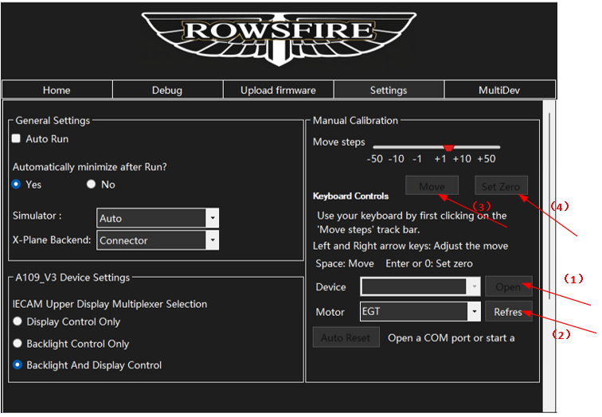
- In dropdown (1), select the connected product and click “Open”. Then use dropdown (2) to select the motor that needs calibration.
If the motor is not listed, click “Refresh” to reload the motor list.
Click “Move” to move the motor for calibration. Finally, click “Set Zero” to save the current position as the zero position.

